Worksheet
Hematoxylin & Eosin (H&E) stain of a neutrophil, macrophage, and foreign body giant cell.
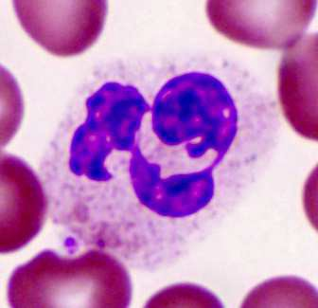
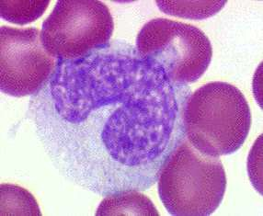
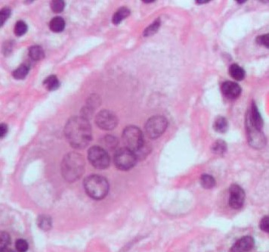
(Caceci) (Caceci) (Krishna)
Neutrophil Macrophage Foreign Body Giant Cells
Neutrophil: Granules in the cytoplasm and “3-lobed” nucleus.
Macrophage: Larger than neutrophils, no granules in the cytoplasm, and one nucleus. Nucleus may be pinched in center, as shown above, or circular.
Foreign Body Giant Cell: Have many nuclei within one cell. FBCs are much larger than macrophages.

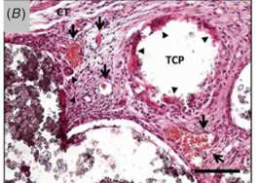
G

(Ghanaati, 2012) G=Granulation Tissue, Arrows=Blood Vessels, TCP=Beta-Tricalcium Phosphate Particles Triangles=Multi-Nucleated Giant Cells, CT=Connective Tissue
Table 1 lists common components in tissue and the color they become after an H&E stain.
Cell Component Color Stained
Erythrocytes (Red Blood Cells) Red
Nuclei Deep Blue
Collagen Pale Pink
Muscle Deep Pink
Basophilic Cytoplasm Purple
Acidophilic Cytoplasm Red
(Table 1)

Table H&E Stain Data

Treatment | Day 3 | Day 7 | Day 14 | Day 21
Slowly Degrading
+ Pepducin + MSC
Quickly Degrading + Pepducin + MSC
Saline Delivery of Pepducin + MSC

Alcian Blue & Orange G Stain of Bone/Cartilage
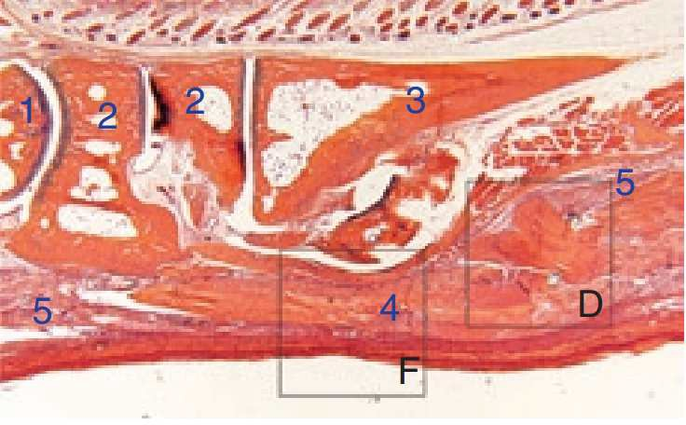 (Basile, 2008) Bone: Sections 1-3. Dark orange, all one color. Tendon Allograft: Section 4. Smooth muscle, all one color, lighter than the bone due to less collagen. Granulation/inflammation tissue: Section 5. Tissue looks “pebbly” and has cells present (blue and orange color).
Table 2 lists common components in tissue and the color they become after an A&O stain.
Tissue/Structure | Color
Osteocytes | Bright Blue Pericellular Rings
Cartilage | Blue/Purple
Bone | Orange
Tendons/Muscle | Lighter Orange or Pink
(Table 2) Recording the Inflammatory Response for Each Image
Use the following tables to write descriptions about each image. Make sure to include which of the following cell types are present and the relative amount of each cell type: neutrophils, macrophages, foreign body giant cells. In addition, note the presence (if any) of granulation tissue and collagen. Also, based off which cell and tissue types are dominant, think about which stage of the inflammatory response is shown.

Table, Alcian Blue & Orange G Data

Treatment | Day 3 | Day 7 | Day 14 | Day 21
Slowly Degrading + Pepducin + MSC
Quickly Degrading + Pepducin + MSC
Saline Delivery of Pepducin + MSC

