LAB MODULE 4: Drug Delivery & Controlled Release
In this lab students will investigate how polymeric cross-linked networks can be used to controllably deliver target molecules through diffusion. The relation between cross-linking density and model drug release (bovine serum albumin: BSA) will be highlighted. In addition, students will draw comparisons between diffusion and tether mediated release strategies.

REFERENCES:
- Lin, C.C. Pharmaceutical Research. 26(3): 631-643. 2009

PRE-LAB REQUIREMENTS:
- Read Lin et al. 2009 in preparation for a brief quiz
- Do prelab calculations (see below)

MATERIALS:
- Methacrylated poly(ethylene glycol) (PEGDM) (2, 10, and 20kD)

MATERIAL |  | MW
PEGDM 2kD | “linear” 2kD PEG with terminal MA functionality | 2,172 g/mol
PEGDM 10kD | “linear” 10kD PEG with terminal MA functionality | 10,172 g/mol
PEGDM  20kD | “linear” 20kD PEG with terminal MA functionality | 20,172 g/mol
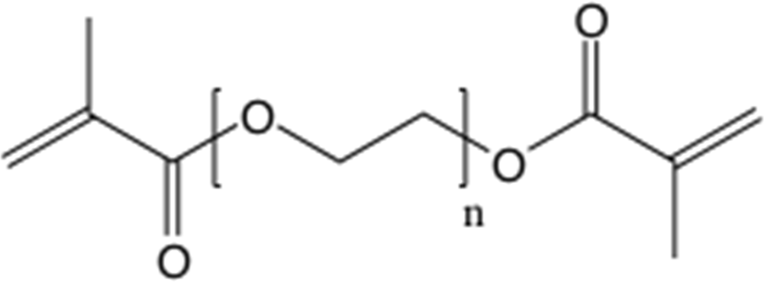
Figure 1. Methacrylated poly(ethylene glycol)
The precursor molecules that will be used in this lab are all linear PEG molecules of varying molecular weight (i.e. length). We will be using a “linear” 2kD PEG, a “linear” 10kD PEG, and a “linear” 20kD PEG. Each end of these PEG molecules has been terminally functionalized with methyl methacrylate, through which radical initiated cross-linking will occur. As previously performed in lab #1, the synthesis of the mesh-networks will take place by exposing the solution phase precursor mixture to UV light in the presence of a radical generating photo-initiator.

PROTOCOL:
This lab is broken into four sections: (1) in lab synthesis of PEGDM networks, (2) time course collection and replacement of protein containing PBS, (3) end-stage assay for extent of protein release, (4) visual

 | Day 1 | Day 2 | Day 3 | Day 4 | Day 9
 | [protein] | [protein] | [protein] | [protein] | [protein]
PEGDM 2kD
PEGDM 10kD
PEGDM 20kD

Prelab Calculations:
For each PEG MW being investigated (2, 10, 20 kDa), perform the necessary calculations to make a solution that is: 10wt% PEG in PBS + BSA with 10% photo-initiator by volume and a total volume of 250μL. Assume the PEG does not add significantly to the volume of the solution; assume the PBS+BSA solution and photo-initiator has the same density as plain PBS. Determine the density of PBS through individual research (cite your source). Neatly write up your prelab calculation; it will be collected at the beginning of the lab and will contribute to your grade.

PEGDM Network Synthesis:
- In labs teams calculate and check 10wt% calculations with TA prior to beginning lab. Each lab group must have checked with a TA before receiving the ok to proceed with the lab. Each group will be assigned a specific molecular weight PEGDM to determine protein release. All the group data will be collected at the end of lab and placed on blackboard for the entire class to analyze in their reports.
- Prepare stock solutions: 10wt% PEGDM in PBS+10 mg/mL BSA with 10% photo-initiator by volume; total volume is to equal 250μL. NOTE: the photo-initiator should be added after PEG is dissolved, adding it too early can cause the gel to polymerize in the tube.
- Mix the solution thoroughly to solubilize the PEG (solutions may need to be aggressively vortexed to fully solubilize the PEG).
- Add 40μL of solution to a cylindrical mold (1mL syringe with tip cut off). Run each gel in triplicate at least (n=3). Place molds under UV-lamp for 10min to induce polymerization.
- Once polymerization is complete transfer gels into 1mL PBS (exact) in a 24-well plate; label samples with team name as well as PEG molecular weight

Collection of Released Protein: (time course)
- Once the BSA containing hydrogels have been synthesized in lab the PBS “bathing solution” will be periodically collected and replaced over a period of 9 days. This is done to ensure that the surrounding PBS does not become saturated with BSA, thus preventing diffusive release from the hydrogel.
- The BSA containing PBS will be labeled and stored in eppendorf tubes in a -80°C freezer
- The process of PBS collection and storage will be carried out by the lab TAs

Assay for Protein Release:
- To determine the amount of protein released from each PEG network a Coomassie Protein assay will be performed against a BSA standard curve
- 10μL of standard or unknown sample will be pipetted into a clear 96-well plate

- 300μL of Coomassie Plus reagent will be added to each well in the 96-well plate
- The plate will be covered and allowed to incubate at room temperature for 10min
- Using a plate reader absorbance of the reagent will be measured at a wavelength of 590nm

1D Diffusion Model

  - Synthesize 250 µL of stock 8.5 wt% PEG solution which will be used to make three linear gels of an assigned molecular weight. The solution should be 10% photoinitiator by volume.
  - The well blocking pegs should be inserted in both ends of each of the three apparatuses per group. Pipette approximately 55 µL of solution into each channel. Remove any air bubbles with the pipette tip before polymerizing. Air bubbles in the gel will result in significant error in the 1D diffusion model and a tendency for the gel to tear.
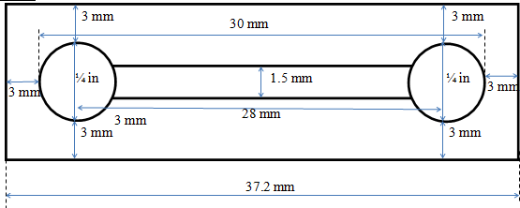
Figure 2. Top view of the 1D Diffusion Apparatus with dimensions
  - Polymerize the gel for 15 minutes under UV light. When the gels have polymerized, remove one of the two well-blocking inserts by rotating the peg as it is pulled upward slowly. Rotating the peg as it is removed will help prevent pulling the gel out of its mold.
  - Place the three molds with one well-blocking insert in each, in a Petri dish. Fill the base of the Petri dish with water to provide a humid environment for the gels. This setup can be seen in Figure 3 below. Position the Petri dish in a location where it will not be moved throughout the remainder of this process or a forcing effect will damage the diffusion experiment.
  - A stock solution of diluted trypan blue is available. The solution is 15% trypan blue by volume in PBS. Pipette approximately 105 µL of the solution into the empty well. This number is imprecise because the volume of these wells varies from apparatus to apparatus. The well should be filled completely without wicking over the edge. Place the Petri dish lid on the Petri dish overnight. Allow the system to sit for approximately 15 hours until 1D diffusion processing.

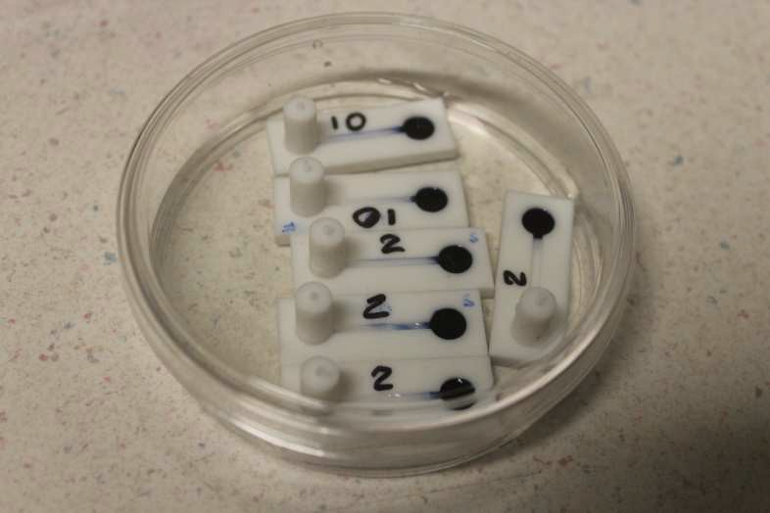
Figure 3. The initial Petri dish arrangement.

1D Diffusion Processing
- Record the length of time since the diffusion process began. Remove the three gels from the molds carefully and place them on the white paper with calibration marks. Images of each gel should be taken with the scale in the image.
- Import an image into ImageJ and convert the image to grayscale as seen in Figure 4 below.
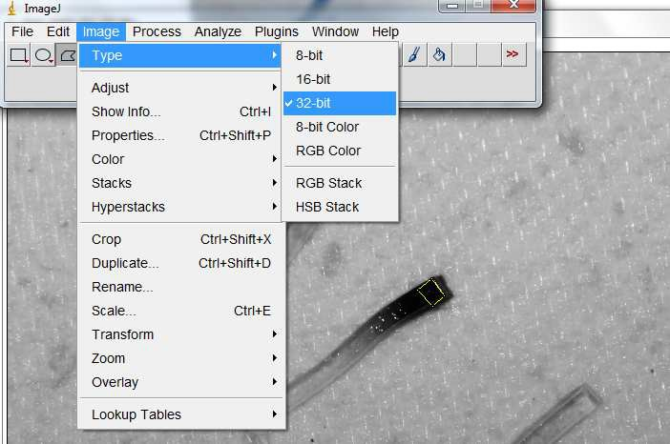
Figure 4. The menu option to view the image in grayscale

- Using the Polygon selection tool, select a square of approximately 2x2 mm (as seen in the yellow box above) and hit ctrl+M to measure. The average intensity of the grayscale image in this 2x2 mm box is output. Move the box along the gel and continue to take measurements until data is collected for each gel sample. Record the average x position of each intensity measurement where the lowest concentration is assumed to be x = 0.

- Assume the highest concentration in the gel to be equivalent to the concentration of the well and the lowest concentration to be zero. Using this information, use linear interpolation to create a concentration scale corresponding to pixel intensities.

- The concentration can be plotted against the coordinate of the concentration and nonlinearly fit in Matlab to a logistic function.

POST-LAB:
Once the in lab requirements are complete students are required to write a formal lab report summarizing their experimental process and presenting their findings. In addition students must answer the following questions:
  - Compare and contrast the key differences between “diffusive release” and “tether mediated” release with respect to controlled drug delivery. Be sure to highlight and discuss rate-limiting steps in each strategy.
  - Make a table and graph of the calibration data used to convert absorbance to concentration of BSA in solution. Show the calibration equation used, being sure to discuss its accuracy.
  - Make a table and graph the relation between total protein release and time for each of the experimental PEGDM groups. Discuss any trends observed.
  - Discuss the mechanism by which BSA was released from the PEGDM hydrogels. Fickian? Kinetic? What are the governing equations that can be used to describe the release, and what are the key parameters?
  - Using your experimental data (for each PEG molecular weight) and the governing equation from question 4, determine the diffusion coefficient (D_{BSA,PEG}) for the BSA in each PEG MW hydrogel.
  - How is the BSA release profile for each PEG molecular weight affected by the hypothetical meshsize/cross-linking density of the polymeric network?
  - Using the Peppas scaling equation
DSolute Gel r
,
DSolute,PBS = 1 − ξ
where r= the hydrodynamic radius of the solute (r=3.3 nm for BSA), DSolute,PBS is the diffusion coefficient for the solute in solution (DBSA,PBS =6.4*10⁻⁷ cm²/s) and ξ is the mesh size of the gel. Using your D_{BSA,PEG} estimates from 5, calculate the mesh size of each hydrogel [1-2].
  - If a larger protein (bigger than BSA) were used to model release from the PEGDM gels how would the release profiles change?
  - Discuss at least three parameters that can be altered to obtain different release profiles under diffusive conditions.

  - Discuss the advantages and disadvantages of using photoinitiated polymerization to produce polymers/hydrogels for protein delivery and tissue engineering applications.
  - Find one other example (from the literature) where molecular delivery (protein, growth factor, drug, etc.) is accomplished through the application of biomaterials. Briefly explain the delivery strategy used and compare/contrast it to the PEGDM gels.
  - Determine and compare algebraic, logistic relationships relating the concentration of trypan blue in each hydrogel vs linear distance for each molecular weight.
  - Using Fick’s second law, estimate the diffusion coefficient for each molecular weight.
  - Discuss the relationship between molecular weight of PEG hydrogels and their diffusion coefficients.

References
- Peppas, Nicholas A. Hydrogels in Medicine and Pharmacy. Boca Raton, FL: CRC, 1986.
- Pluen, Alain, Paolo Netti, Rakesh Jain, and David Berk. "Diffusion of Macromolecules in Agarose Gels: Comparison of Linear and Globular Configurations." Biophysical Journal 77 (1999): 542-52.

