Lab Module 3: Cell Culture and Cell-Material Interactions
In this lab students will learn and utilize sterile techniques for cell culture applications, including culturing, enumeration, and imaging mouse embryonic fibroblasts (3T3s). Within this lab students will investigate how hydrogel materials properties can be altered to encourage cellular adhesion and spreading. The relationship between material functionality and cell number, shape, and adhesion will be monitored over time.

References:
1. Benoit, D.S. Biomaterials. 26(25): 5209-5220. 2005

Pre-lab Requirements:
- Read Benoit. 2005 in preparation for a brief quiz.
- Download and explore ImageJ from the NIH.
- There are no pre-lab calculations for this lab.

Materials:
- Dimethacrylated poly(ethylene glycol) (PEGMA)
- Acrylate-PEG RGDSG peptide (Hern, D.L. J. Biomed. Mat. Res. 39(2): 266-276. 1998)

MATERIAL |  | MW
PEGMA | linear 2kD PEG with terminal methacrylate functionalities | 2,000 g/mol
Acr-PEG-RGDSG | linear RGDSG peptide conjugated to PEG-(mono)acrylate | 3,890 g/mol
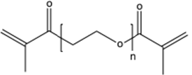
Figure 1. Dimethacryalted poly(ethylene glycol); (PEGMA)
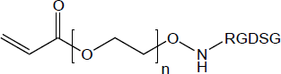
Figure 2. Acrylated poly(ethylene glycol) RGDSG peptide; (Acr-PEG-RGDSG)

The precursor molecules that will be used in this lab are both “linear” in shape and have reactive functionalities through which cross-linking and network formation will occur. The first molecule (PEGMA; Fig.1) has methacrylate functionality at both ends and comprises the bulk of the hydrogel materials. The second molecule (Acr-PEG-RGDSG; Fig.2) is comprised of a RGRSG adhesive peptide that has been functionalized with an acrylated-PEG monomer through the peptides N-terminus. This molecule incorporates into the hydrogel through the acrylate functionality and presents the cell adhesive peptide RGDSG to promote cell-material interactions. As previously performed, the synthesis of the hydrogels will take place by exposing solution phase precursor mixture to UV light in the presence of a radical generating photo-initiator.

Protocol:
This lab is broken into three sections: (1) synthesis of PEGDA networks (with and without adhesive ligand), (2) seeding 3T3s on synthesized networks with initial light microscopy and fluorescent microscopy imaging, and (3) follow-up monitoring of cellular adhesion through number of adherent cells, cell shape, adhesion area, spindle factor, and cell viability.

 | Day 0 | Day 1 | Day 2 | Day 3
 | adhesion # cell area spindle factor | adhesion # cell area spindle factor | adhesion # cell area spindle factor  Live-Dead Staining | adhesion # cell area spindle factor
Tissue Culture Plastic
PEGMA + RGDSG
PEGMA - RGDSG

Synthesis of PEGDA Networks:
Since the focus of this lab is on tissue culture techniques, the PEGMA networks will be synthesized prior to the lab period. The techniques used were identical to those previously examined in labs 1 and 2 but in an effort to focus on the aspect of cell culture this step has been done for each group. Both networks will be made with 10 wt% of linear, 2kDa PEG, in PBS, with 10 vol% LAP photoinitiator. The PEGMA + PEGDA-RGDSG hydrogels will also contain 5 mM of PEGDA-RGDSG.

Cell Culture Techniques:
  - Under the guidance of a TA teams will be in charge of seeding 3T3s onto their networks. During this time, teams will learn sterile techniques for working in a cell culture environment as well as how to care for and maintain cells. Groups will first observe a TA demonstration and then receive hands on experience.
  - A monolayer of 3T3s will be removed from their culture flask using trypsin. This will cause the cells to detach from the surface. Cells will then be counted using a hemocytometer and trypan blue staining and a desired concentration of cells will then be seeded on top of the synthesized networks.

    - 3T3s will be grown to confluence in a T75 prior to lab. Media will be removed, and the cells washed with 10 mL warm PBS. PBS will then be removed. 2 mL of warm 1X Trypsin/EDTA will be added to the flask, and the flask rotated to ensure even coverage. Flasks will be incubated at 37 C for 5 minutes to allow cells to detach from the surface. Trypsin will then be quenched with 8 mL media, and the T75 placed on its end to reduce the amount of re-adhesion which occurs during cell counting.
    - 40 uL of cell suspension will be combined with 40 uL of trypan blue in a small vial. 10 uL of cell/trypan solution will be dispensed in each side of a

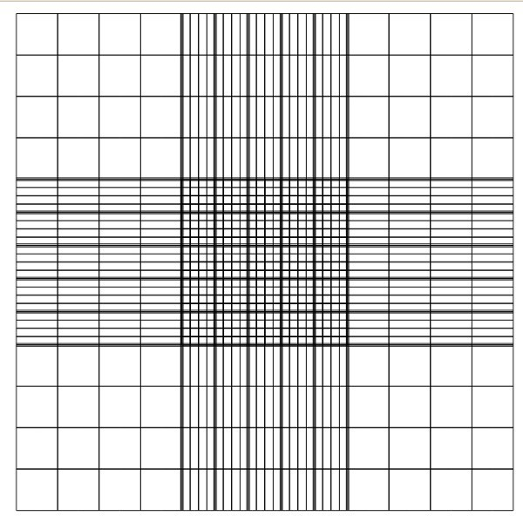
hemocytometer, and the number of cells counted. The equation to determine cell density is:
1
2
3
4

Cells
X
mL
= # cells counted # squares counted
∗ 2 (dillution factor) ∗ 10
4 cells
mL

Figure 3: Hemocytometer. The squares referred to in the cell density equation are highlighted in red. The four corner squares should be counted on each side of the hemocytometer. Modified from: "The Hemocytometer (counting Chamber)." MicrobeHunter.com. Web. 29 Feb. 2012. <http://www.microbehunter.com/2010/06/27/the-hemocytometer-counting-chamber/counting_chamber7/>.
    - Cells will be diluted as necessary to make a solution that has a total volume of 9 mL with 2,000 cells/mL in a conical tube.
    - 1 mL of the cell solution (a density of 10,000 cells/well) will be allquoted into the wells of a 24 well plates, with the well containing either
      - 1) tissue culture plastic alone (n=2 wells)
      - 2) a PEG gel (n=2 wells) or
      - 3) a PEG-RGDS gel (n=2 wells).
  - After seeding cells, group will use an inverted light microscope to image cells and analyze the number of adherent cells, cell contact area, and spindle factor using ImageJ.
  - Live-dead assays will also be conducted at the 48 hour (Day 2) time point using the fluorescent microscopes. Cells will be stained with green fluorescent calcein-AM indicating living cells and with red fluorescent ethidium homodimer-1 indicating dead cells. The staining solution will be provided by the TAs and samples will need to be incubated for at least 30 min prior to imaging. Images will be taken for post-lab analysis.

Time-Course Follow-up:
In addition to the in-lab experimentation, teams are going to be required to send representatives to collect data over time. The details of this will be discussed further in lab, but a rough outline of data collection points are as follows: Day 0, 1, 2, 3. Each group will be responsible for feeding their cells with fresh media at each time point.
For this lab, data will NOT be pooled and posted online. Each group is responsible for coming in at each time point to collect images to share with their classmates. Any group which does not send a team member will miss out on important data and will lose points.

Post-lab:
Once the in lab requirements are complete students are required to write a formal lab report summarizing their experimental process and presenting their findings. In addition students must answer the following questions:

  - Explain why “unmodified” PEG materials are resistant to cell adhesion?

  - Create plots of number adherent cells, average adhesion area, and spindle factor as a function of time. Explain any observed changes in cell shape as well as any trends that are observed.

  - Using published literature to briefly explain the background of the RGD sequence (what proteins is it derived from and why is it utilized in tissue engineering?). How do cells interact with RGD (be sure to include specific integrins that bind to this sequence and relevant references)?

  - What are the advantages of incorporating short peptide sequences into scaffolds instead of using entire proteins?

  - How might increasing “RGD” concentration effect cell-PEG interaction and overall cell morphology? What cellular process(es) may be affected? What is a possible negative consequence of increasing “RGD” concentration too much?

  - We use methacrylated PEG as the main component of our hydrogel, but the PEG which is functionalized with RGDSG is acrylated. While methacrylate and acrylate groups are similar, they are not identical. How might the differences in these functional groups affect the final hydrogel network? What potential problems could you foresee occurring as a result of using two different functionalities?

  - How could you generate a peptide concentration gradient? Outline an experiment to examine cell migration on a gradient surface. Hypothesize what you would expect to happen to cells on a gradient of cell adhesive peptides.

  - Plot the percent live cells for each material. Discuss any differences observed, and hypothesize as to the reason for the difference/lack of difference.

  - Discuss the advantages and differences of light microscopy and fluorescent microscopy with respect to cell-material interactions.

