Lab Module 2: Materials Degradation – Surface vs. Bulk
In this lab students will investigate how polymeric chemical structure can be used to control the degradation properties of the crosslinked network. The relationship between chemical structure and both mass loss, and change in mechanical properties over time will be investigated. Using microscopes, material degradation will be visually tracked over time and correlated to the quantitative results from the mass loss aspect of the experiment. Additionally, students will gain an understanding of how controlling material degradation can provides advantageous in numerous tissue-engineering applications.

References:
1. Metters, A.T. Polymer. 41(11): 3993-4004. 2000

Pre-lab Requirements:
- Read Metters et al. 2000 in preparation for a brief quiz

Materials:
- Methacrylated poly(lactic acid) functionalized poly(ethylene glycol) (PEG)
- Methacrylated sebacic acid

MATERIAL |  | MW
PEG-PLA-MA | linear 4kD PEG with terminal PLA and MA functionality | 4,380 g/mol
MSA | linear sebacic acid with terminal MA functionalities | 338 g/mol
MAA | Linear adipic acid with terminal MA functionalities | 282 g/mol
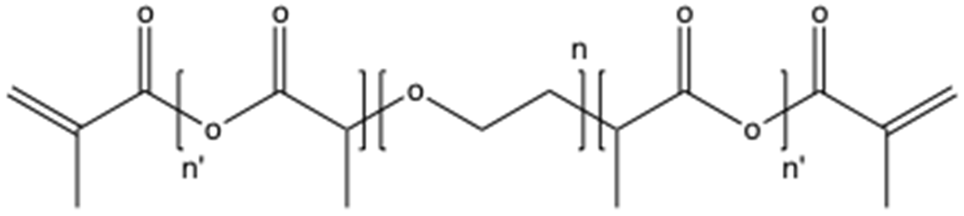
Figure 1. Methacrylated poly(ethylene glycol)-poly(lactic acid); (PEG-PLA-MA)
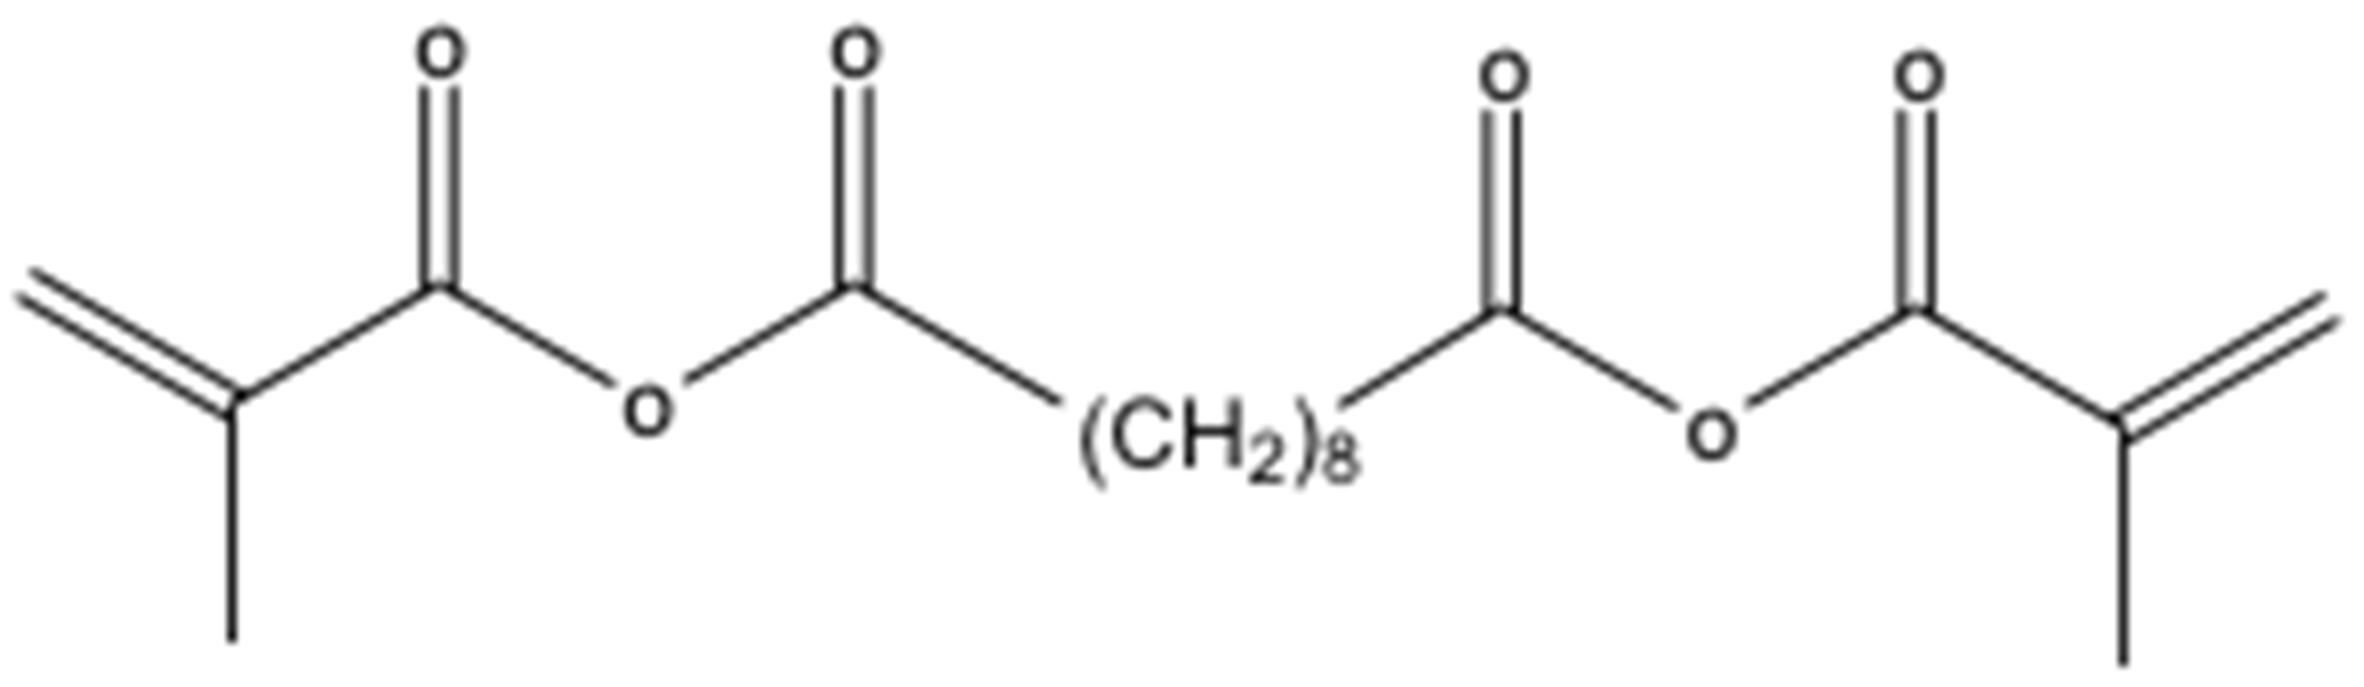
Figure 2. Methacrylated sebacic acid; (MSA)
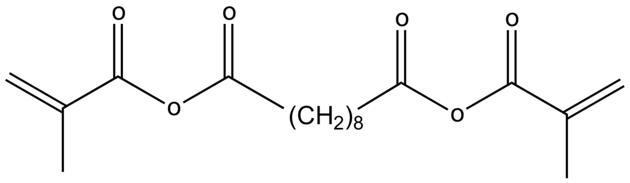

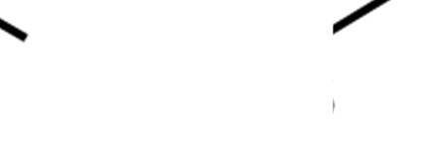
(CH2)4
Figure 3. Methacrylated adipic acid; (MAA)

The precursor molecules that will be used in this lab are “linear” in shape, with each molecule having two reactive methacrylate-functionalized end groups through which cross-linking and network formation will occur. The first molecule (PEG-PLA-MA; Fig.1) was initially modified to contain terminal lactide groups through the process of ring-opening dl-lactide. Following the addition of lactide the PEG molecules were terminally functionalized with methyl methacrylate. The second molecule (MSA; Fig.2) was synthesized by terminally functionalizing sebacic acid with methyl methacrylate. The third molecule (MAA; Fig.3) was synthesized by terminally functionalizing adipic acid with methyl methacrylate. As previously performed in lab #1, the synthesis of the mesh-networks will take place by exposing the solution phase precursor mixture to UV light in the presence of a radical generating photo-initiator.

Protocol:
This lab is broken into three sections: (1) in lab synthesis of PEG-PLA-MA and MSA networks,
(2) initial microscopic imaging and size/mass/mechanical testing, and (3) follow-up imaging, time course dependent mass loss, and change in mechanical properties.

 | Day 0 | Day 1 | Day 3 | Day 8 | Day 11
 | mass / size /  mech. | mass / size /  mech. | mass / size /  mech. | mass / size /  mech. | mass / size /  mech.
PEG-PLA-MA
MSA

Prelab Calculations:
Perform the necessary calculations to make a solution that is 10wt% PEG-PLA-MA in PBS with 10% photo-initiator by volume and a total volume of 250μL. Assume the PEG-PLA-MA does not add significantly to the volume of the solution; assume the photo-initiator has the same density as PBS. Determine the density of PBS through individual research (cite your source).
Neatly write up your prelab calculation; it will be collected at the beginning of the lab and will contribute to your grade.

PEG-PLA-MA Network Synthesis:
  - In labs teams calculate and check 10wt% calculations (for PEG-PLA-MA only) with TA prior to beginning lab. Each lab group must have checked with a TA before receiving the ok to proceed with the lab. Each group will be responsible for their own degradation time course for both the PEG-PLA-MA as well as the MSA. All the group data will be collected at the end of lab and placed on blackboard for the entire class to analyze in their reports.
  - Prepare stock solutions: 10wt% PEG-PLA-MA in PBS with 10% photo-initiator by volume; total volume is to equal 250μL. NOTE: the photo-initiator should be added after PEG is dissolved, adding it too early can cause the gel to polymerize in the tube.
  - Mix the solution thoroughly to solubilize the PEG (solutions may need to rest on the benchtop for 5-10min to ensure that all PEG is dissolved).
  - Add 40μL of solution to a cylindrical mold (1mL syringe with tip cut off). Run each gel in triplicate at least (n=3). Place molds under UV-lamp for 10min to induce polymerization.

  - Once polymerization is complete transfer gels into PBS in a 24-well plate; label samples.
  - Use calipers to measure the height and diameter of the cylindrical networks, and obtain the initial mass of the samples. NOTE: to obtain an accurate mass the gels should not have excess water on the surface, so GENTLY pat the gels dry using a paper towel.
  - Mechanical compression testing will be performed in the mechanical testing lab using a 5N load cell, as in Lab 1. The desired output of these tests is the Young’s modulus of each sample. Teams will be responsible for bringing clearly labeled samples to the TA who will be responsible for performing the mechanical testing.

  - Microscopy imaging will be performed in the microscopy lab using stereo light microscopes. Although it is unnecessary to take a picture of the entire sample, it may be beneficial to have an edge in focus.

MSA/MAA Network Synthesis:
  - The Monday lab group with use MSA, the Tuesday lab group will use MAA. All the data will be pooled and posted on blackboard so that all students can compare degradation of these two poly-anhydrides.

  - The synthesis of the MSA/MAA network is similar to the PEG-PLA-MA network in the sense that the precursor molecules are reacted with a photo-initiator under UV-light however; the MSA/MAA network is NOT solubilized in a liquid solvent. Instead the reaction is performed in a solid-phase “paste” that will be spread into molds and cross-linked.
  - MSA/MAA precursor will be massed out and to it will be added 0.1wt% DMPA (2,2-Dimethoxy-2-phenylacetophenone) photo-initiator. This “paste” will then be mixed in a glass scintillation vial until uniform.

  - With a glass slide as a base, small binder clips will be used to hold in place a circular Teflon mold. Using a spatula, fill the Teflon mold with the “paste” from Step 3. Once filled, gently remove the binder clips and place the last glass slide on top (as shown in Figure 4). Ensure no air bubbles are trapped in the mold and use the binder clips to hold the stack together.
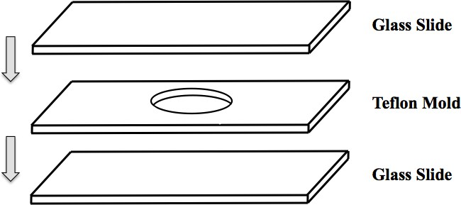
Figure 4. Teflon mold setup for MSA photopolymerization

  - Place molds under UV-lamp for 10min to induce polymerization.
  - Once polymerization is complete transfer gels into PBS in a 24-well plate; label samples.
  - As in section 1, use calipers to measure the height and diameter of the cylindrical networks, and obtain the initial mass of the samples. NOTE: to obtain an accurate mass the gels should not have excess water on the surface, so GENTLY pat the gels dry using a paper towel.
  - Mechanical compression testing will be performed in the mechanical testing lab using a 5N load cell, as performed with the PEG-PLA-MA network.
  - Microscopy imaging will be performed in the microscopy lab using stereo light microscopes. Although it is unnecessary to take a picture of the entire sample, it may be beneficial to have an edge in focus.

Time-Course Follow-up:
  - In addition to the in-lab synthesis, teams are required to send representatives to collect data over an extended degradation time course.
    - At each time point, all four measurements will be collected (young’s modulus, height, diameter, weight), as well as stereo light microscope photos.
    - Data collection points are as follows: Day 0, 1, 3, 8, 10.
    - More details regarding scheduling, data assembly, ect. for the time-course follow-up will be discussed in lab.

Post-lab:
Once the in lab requirements are complete students are required to write a formal lab report summarizing their experimental process and presenting their findings. In addition students must answer the following questions:
- Compare and contrast the key differences between bulk and surface degradation.
- Create a graph illustrating the relation between mass loss and time (similar to Metters et al.2000 Fig. 2) for each of the experimental groups. Discuss any trends observed.
- Create a graph illustrating the relation between volume loss and time for each of the experimental groups. Discuss any observed trends.
- Create a graph illustrating the relation between Young’s modulus and time (similar to
Metters et al.2000 Fig. 4b) for each of the experimental groups. Discuss any trends observed.
- From the graphs created in 2-4, explain which network(s) were bulk degrading and which were surface degrading.
- What is the root cause for the degradation of each network? Using figures 1, 2 and 3, explain which structural groups contribute the mechanism of degradation and how they contribute.

- From the graphs created in 2-4, compare and contrast the degradation of the MSA and the MAA. Using figures 2 and 3, explain any differences which are observed.

- Do the time course images of each material support the degradation mechanisms associated with these materials as discussed in questions 5 and 6? Annotate images with any distinct features of bulk vs. surface degradation, and discuss how this compares to the expected degradation behavior. As you only made either MSA or MAA, you are only responsible for question 8 for the material you made- you do not have to obtain images for the other MSA/MAA samples.
- For each network (PEG-PLA-MA, MSA, MAA) describe a tissue-engineering application in which they may be used. Does one network provide any advantage over the other?
- If a drug was incorporated into each of these two networks (assume size of drug is large compared to the mesh size of both networks), and the release of the drug was to be monitored over time, sketch out the drug release profile for each network and briefly explain the anticipated trend.

