Lab Module 1: General Mechanical Properties
In this lab students will investigate how molecular precursors can be used to alter end-stage mechanical properties of a formed hydrogel mesh network. The relationship between mesh-size and stiffness will particularly be highlighted and comparisons will be drawn between naturally occurring tissues and fabricated networks. In addition students will gain an understanding of how hydrogel mechanics influence cellular behavior through mechanotransduction. While the shape and mechanical properties of hydrogels lend themselves to be tested in compressive testing, other more rigid materials are tested in tension. The fracture response and post yield behaviors to tensile loading of four materials will also be analyzed.

References:
- Engler, A.J.. Cell. 126: 677-689. 2006
- Fairbanks, B.D., Adv Mater. 21: 5005-5010. 2009
- Peppas, N.A., Adv Mater. 18: 1345-1360. 2006

Pre-lab Requirements:
- Read Engler et al. 2006 in preparation for a brief quiz
- Complete necessary wt% calculations for various hydrogel compositions (see below)

Materials:
- Norbornene functionalized poly(ethylene glycol) (PEG) of various “arms” (2, 4, 8)
- Thiol functionalities of various “arm” (2, 3, 4)

MATERIAL |  | MW | Density
PEG-2,000 | “2 arm” poly(ethylene glycol)-norbornene | 2,200 g/mol | -
PEG-10,000 | “4 arm” poly(ethylene glycol)-norbornene | 10,400 g/mol | -
PEG-20,000 | “8 arm” poly(ethylene glycol)-norbornene | 20,800 g/mol | -
2SH | 3,6-Dioxa-1,8-Octanedithiol | 182.30 g/mol | 1.12 g/mL
3SH | Trimethylolpropane Tris (3-Mercaptopropionate) | 398.56 g/mol | 1.21 g/mL
4SH | Penaerythritol Tetrakis (3-Mercaptopropionate) | 488.66 g/mol | 1.28 g/mL
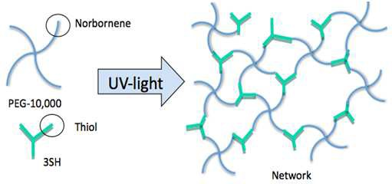
PEG precursor molecules included a 2kDa single arm “strand”, a 10kDa four-arm “cross”, and a 20kDa eight-arm “star”. These precursors were modified to contain terminal reactive norbornene groups enabling radical polymerization to occur through UV photopolymerization. Thiol-linker molecules included species of single, double, and triple thiol reactive species. Synthesis of the hydrogel network will take place by exposing the solution phase precursor mixture to UV light.

Protocol:
This lab is broken into three sections: (1) investigation of precursors on hydrogel mechanics,
(2) investigation of network growth mechanism, and (3) tensile properties of a variety of biomaterials. In the first section a series of nine total hydrogel compositions will be examined (listed below), and it is expected that students will arrive at lab having performed the necessary calculations to create the required wt% solution of each. In the second section only a single hydrogel composition will be investigated (PEG10,000-3SH). In the third section, four solid metal and polymer samples will undergo tensile testing for fracture analysis.

 | 2SH | 3SH | 4SH
PEG-2,000
PEG-10,000
PEG-20,000

Influence of Precursors on Hydrogel Mechanics:
Prelab Calculations: For each PEG/thiol combination, determine the mass of PEG and volume of DMSO, thiol, and photoinitiator which must be combined to make a solution that is: 10 wt% (10k and 20k PEG) or 20 wt% (2k PEG) PEG, has a 1:1 molar ratio of norbornene functionality to thiol functionality, has 10 vol% photoinitiator, and totals 500 µL. Make sure that your weights and volumes are physically measurable (a minimum of 10 mg or 1 µL-increase total volume if necessary to meet this requirement).

  - Check wt% calculations with TA prior to beginning lab. Each member of the lab group must have checked with TA before the group will receive the ok to proceed with the lab. Each group will be assigned a specific “PEG-molecule” which they will be responsible for testing with each possible thiol. All the group data will be collected at the end of lab and placed on blackboard for the entire class to analyze in their reports.
  - Prepare stock solutions: 10wt% PEG (10, 20kDa) in DMSO (20wt% for 2kDa-PEG) is combined with one-to-one molar ratio of thiol-linker; 10% photo-initiator by volume is also added, total volume is to equal 500μL. NOTE: the photo-initiator should be added after PEG is dissolved and thiol has been added. Adding it too early can cause the gel to polymerize in the tube due to absorbance of ambient room light.
  - Mix each solution thoroughly to solublize the PEG (solutions may need to rest on the benchtop for 5-10min to ensure that all PEG is dissolved).
  - Add 40μL of solution to a cylindrical mold (1mL syringe with tip cut off). Run each gel in triplicate at least (n=3). Place molds under UV-lamp for 10min to induce polymerization.
  - Once polymerization is complete transfer gels into DMSO in a 24-well plate. Make sure to label samples, and await instructions for mechanical testing.
  - Mechanical compression testing will be performed in the mechanics lab on the second floor of Goergen Hall using a 5N load cell. The desired output of these tests is the Young’s Modulus of each sample. Teams will be assisted in this process.

Determine Network Growth Mechanism:
  - Following the protocol outlined in Section (1) of this lab, prepare a stock solution of PEG10,000-3SH with a total volume of 750μL.
  - Perform a series of time dependent photopolymerizations. The goal here is to determine how the mechanics of the mesh network evolve over the time course of 10min. It is suggested that samples are polymerized for: 10sec, 15sec, 30sec, 2min, 6min, and 10min.
  - As in Section (1), Once polymerization is complete transfer gels into DMSO in a 24-well plate. Make sure to label samples, and await instructions for mechanical testing.

Tensile Properties of a Variety of Biomaterials:
Follow these instructions for each of four material samples: annealed steel, cold-rolled steel, aluminum and “plastic.”
  - Take pictures of each unbroken tensile bar using the stereo microscopes in the microscopy lab.
  - For the annealed steel, cold-rolled steel and aluminum samples, open the “template003.ds” activity file in DataStudio. For the “plastic” sample open “template010.ds” activity file.
  - Load the sample into the clamps of the PASCO stress/strain apparatus. Make sure the sample is tightened into place sufficiently. The black bar should be close to the silver colored load cell device but not touching. The tensile bar should be slightly bent before the test is run. Zero the load cell.
  - Click the “start” button in DataStudio to begin collecting data and begin turning the handle to apply tension to the tensile bar. When the bar breaks, stop the program from collecting data and remove the sample.
  - Using the linear fit tool determine the modulus of the material and record it on a piece of paper. Take a screenshot of the plot and save a copy for the post-lab.
  - The toughness, or area under the stress-strain curve, is plotted simultaneously. The final value of this curve is the total value toughness. Record the toughness of each sample. This value can be obtained in tabular form as seen below

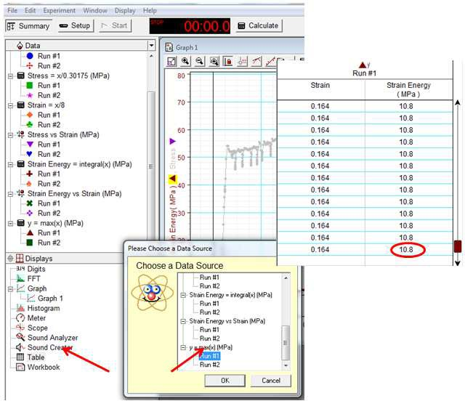
  - Take the broken samples back to the stereo microscopes and take images of the fracture patterns. Give students broken glass to compare fracture pattern.

Post-lab:
Once the in lab requirements are complete students are required to write a formal lab report summarizing their experimental process and presenting their findings. In addition students must answer the following questions:
Section (1): Influence of Precursors on Hydrogel Mechanics
    - Create a bar graph illustrating Young’s modulus for each of the experimental groups and explain. Discuss any trends observed between experimental groups.
    - Relate the experimental Young’s modulus back to the starting precursor molecules for each experimental group. Be sure to discuss the apparent influence that “arm number” has on overall mechanics. Does your data follow the hypothesized trend? If not propose some reasons why this might be the case.

    - Calculate the mesh-size of each sample (data provided and equations from Peppas. 2006) and relate to the observed Young’s modulus for each experimental group. Plot mesh-size vs. thiol linker for each of the PEG molecules. Is mesh size correlated with modulus?

 ν  2
1 2  V  ln(1−ν_{2,s}) +ν_{2,s} +χ₁ν_{2,s}

= − ₁
: Equation 1.

Mc Mn
ν2,s
 13 −ν2,s 
 
2



1
−1  2C M  2
ξ=ν2,s 3 n c  l : Equation 2.
 Mr 
Q = swelling ratio (volume wet polymer over volume dry polymer): unitless v = specific volume of polymer: 0.88mL/g
V₁ = molar volume of solvent (approximate as water): 18.01mL/mole
χ₁ = polymer solvent interaction (0.6): unitless
M_{n} = molecular weight of polymer chain (PEG-2,000/PEG-10,000/PEG-20,000): g/mole C_{n} = Flory characteristic ratio (6.2 for PEG): unitless
M_{r} = molecular weight of PEG repeat: 44g/mole
l = length of bond along polymer backbone: 0.154nm v_{s,2} = 1/Q: unitless

Data:

PEG | Thiol | Swelling Ratio (Q) | PEG | Thiol | Swelling Ratio (Q) | PEG | Thiol | Swelling Ratio (Q)
2kD | 2SH | - | 10kD | 2SH | 18.68 | 20kD | 2SH | 19.39
 | 3SH | 11.05 |  | 3SH | 11.20 |  | 3SH | 8.02
 | 4SH | 5.71 |  | 4SH | 9.85 |  | 4SH | 6.45
    - Refer to Engler.2006 and explain how the Young’s modulus of each experimental group might influence cells cultured on the materials surface. Which samples would influence specific lineage differentiation?

Section (2): Determine Network Growth Mechanism
- Plot Young’s modulus as a function of polymerization time and explain.
- Explain step-growth polymerization. Explain chain-growth polymerization.
- Explain how the plot in (1) explains the mechanism of hydrogel formation.

Section (3): Tensile Properties of a Variety of Biomaterials
- Which material has the highest ultimate strength? Which material has the highest Young’s modulus?
- What is the toughness of each material? How does this relate to the post-yield behavior of each material? Discuss the relative ductility of each material.
- Compare and contrast the fracture behavior of each material.
- Explain why tensile bars of glass and/or other ceramics in the same shape examined in this experiment may not be compatible with this tensile testing machine.

